**Sample IRJASH Template, Bold,Times New Roman Font,Size 16 1.5 Line spacing**

*First Author1, Second Author2, Third Author3, (Times New Roman Font Size 12&Italic)*

*1First Author Affiliation & Address (Times New Roman Font Size 12&Italic)*

*2Second Author Affiliation & Address*

*3Example: Professor, Dept. of abc Engineering, abc college, state, country (Times New Roman Font Size 12&Italic)*

|  |
| --- |
| **Abstract** |
| *An abstract summarizes, in one paragraph (usually), the major aspects of the entire paper in the following prescribed sequence. The abstract of your paper must 250 words or less. This electronic document is a “live” template. The various components of your paper [title, text, heads, etc.] are already defined on the style sheet, as illustrated by the portions given in this document. Do not use special characters, symbols, or math in your title or abstract. The authors must follow the instructions given in the document for the papers to be published. This template, modified in MS Word 2007 and saved as a “Word 97-2003 Document (Size 12, Italic & Times new roman font)*  ***Keywords: (Size 10 & Bold) Key word1, Key word2, Key word3, etc (Minimum 4 to 6 key words) (Size 12, Italic & Times new roman font)*** |

**1. Introduction (Bold, Size 12, Times New Roman font***)*

This document is template. We ask that authors follow some simple guidelines. In essence, we ask you to make your paper look exactly like this document. The easiest way to do this is simply to download the template, and replace (copy-paste) the content with your own material. Number the reference items consecutively in square brackets (e.g. [1]). However, the authors name can be used along with the reference number in the running text. The order of reference in the running text should match with the list of references at the end of the paper.(Times New Roman Font Size 12)

**1.1 Sub Heading 1 (Bold, Size 12, Times New Roman font***)*

Before you begin to format your paper, first write and save the content as a separate text file. Keep your text and graphic files separate until after the text has been formatted and styled. Do not use hard tabs, and limit use of hard returns to only one return at the end of a paragraph. Do not add any kind of pagination anywhere in the paper. Do not number text heads-the template will do that for you.

Finally, complete content and organizational editing before formatting. Please take note of the following items when proofreading spelling and grammar:

**1.2 Sub Heading 2**

Sample paragraph, The entire document should be in Times New Roman font. Type 3 fonts must not be used. Other font types may be used if needed for special purposes.

**2. Heading 2**

IRJASH Template sample paragraph .Define abbreviations and acronyms the first time they are used in the text, even after they have been defined in the abstract. Abbreviations such as IEEE, SI, MKS, CGS, sc, dc, and rms do not have to be defined. Do not use abbreviations in the title or heads unless they are unavoidable. The equation mentioned shown in below and its (Font size 12, Times New Roman, Equation Mentioned number with Double bracket)

$A=πr^{2}$ (1)

**Table.1. Sample Table format**

|  |  |  |  |
| --- | --- | --- | --- |
| **Preparation of Manuscript** | | | |
| Margins          : Top | 0.5” | Bottom | 0.5” |
| Left | 0.5” | Right | 0.5” |
| Margin  : Narrow | Font | Times New Roman / 12 pt |  |
| Title of paper  : 16 Point | Heading | 12 Point |  |
| Sub Heading   :12 Point | Spacing | Single line spacing |  |



**Chart.1. Name of the chart**

IRJASH sample template format ,Define abbreviations and acronyms the first time they are used in the text, even after they have been defined in the abstract. Abbreviations such as IEEE, SI, MKS, CGS, sc, dc, and rms do not have to be defined. Do not use abbreviations in the title or heads unless they are unavoidable.

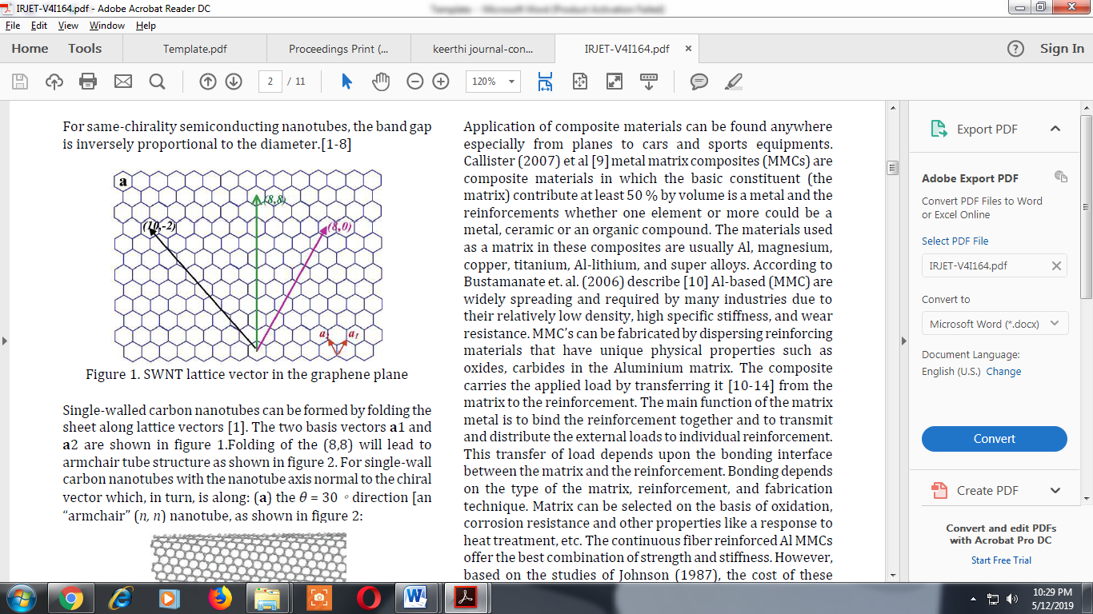

**Fig.1. Name of the figure**

Sample paragraph Define abbreviations and acronyms the first time they are used in the text, even after they have been defined in the abstract. Abbreviations such as IEEE, SI, MKS, CGS, sc, dc, and rms do not have to be defined. Do not use abbreviations in the title or heads unless they are unavoidable.

After the text edit has been completed, the paper is ready for the template. Duplicate the template file by using the Save As command, and use the naming convention prescribed by your conference for the name of your paper. In this newly created file, highlight all of the contents and import your prepared text file. You are now ready to style your paper.

**Conclusions**

IRJASH sample template format, Conclusion content comes here. Conclusion content comes here Conclusion content comes here Conclusion content comes here Conclusion content comes here Conclusion

**Acknowledgement (Optional)**

The authors can acknowledge any person/authorities in this section. This is not mandatory.

**References**

**Journals**

1. Dai, H. (2002). Carbon nanotubes: Synthesis, integration, and properties. Accounts of Chemical Research, 35(12), 1035–1044.
2. Ebert, L. B. (1997). Science of fullerenes and carbon nanotubes. Carbon.35(3),437-438
3. [3] Dai, H. (2001). Nanotube Growth and Characterization. Carbon Nanotubes SE - 3, 80, 29–53.
4. Dekker, C. (1999). Carbon Nanotubes as Molecular Quantum Wires. Physics Today, 52(5), 22.
5. McEuen, P. L. Single-wall carbon nanotubes. Phys. World 2000,13 (6), 31-36.

**Book**

1. H. S. Nalwa, Editor, “Magnetic Nanostructures”, American Scientific Publishers, Los Angeles,(2003).

**Chapter in a Book**

1. H. V. Jansen, N. R. Tas and J. W. Berenschot, “Encyclopedia of Nanoscience and Nanotechnology”, Edited H. S. Nalwa, American Scientific Publishers, Los Angeles,vol. 5,(2004), pp.163-275.11.4.

**Conference Proceedings**

1. J. Kimura and H. Shibasaki, “Recent Advances in Clinical Neurophysiology”,Proceedings of the 10th International Congress of EMG and Clinical Neurophysiology, Kyoto, Japan, (1995)October 15-19.

**Patent**

1. C. E. Larsen, R. Tripand C.R. Johnson, “Methods for procedures related to the electrophysiology of the heart”,U.S. Patent 5,529,067, (1995)June25